**1. <!DOCTYPE>**

The <!DOCTYPE> declaration must be the very first thing in your HTML document, before the <html> tag.

The <!DOCTYPE> declaration is not an HTML tag; it is an instruction to the web browser about what version of HTML the page is written in.

for example.

<!DOCTYPE html>  
<html>  
<head>  
<title>Title of the document</title>  
</head>  
  
<body>  
The content of the document......  
</body>  
  
</html>

**Output :**

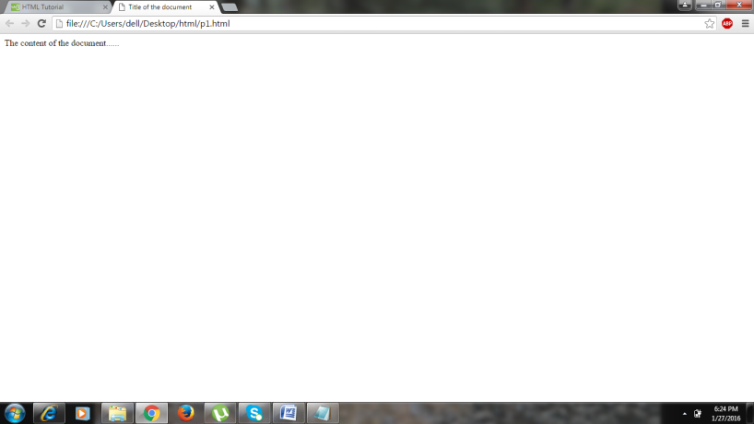

**2.<acronym>**

The <acronym> tag defines an acronym.

An acronym must spell out another word. For example: NASA, ASAP, GUI.

Marking up acronyms can give useful information to browsers, translation systems and search-engines.

for example.

<!DOCTYPE html>

<html>

<body>

<h1>hello world!!!</h1>

Can I get this <acronym title="as soon as possible">ASAP</acronym>?

<p><strong>Note:</strong> The acronym element is not supported in HTML5.</p>

</body>

</html>

**Output :**

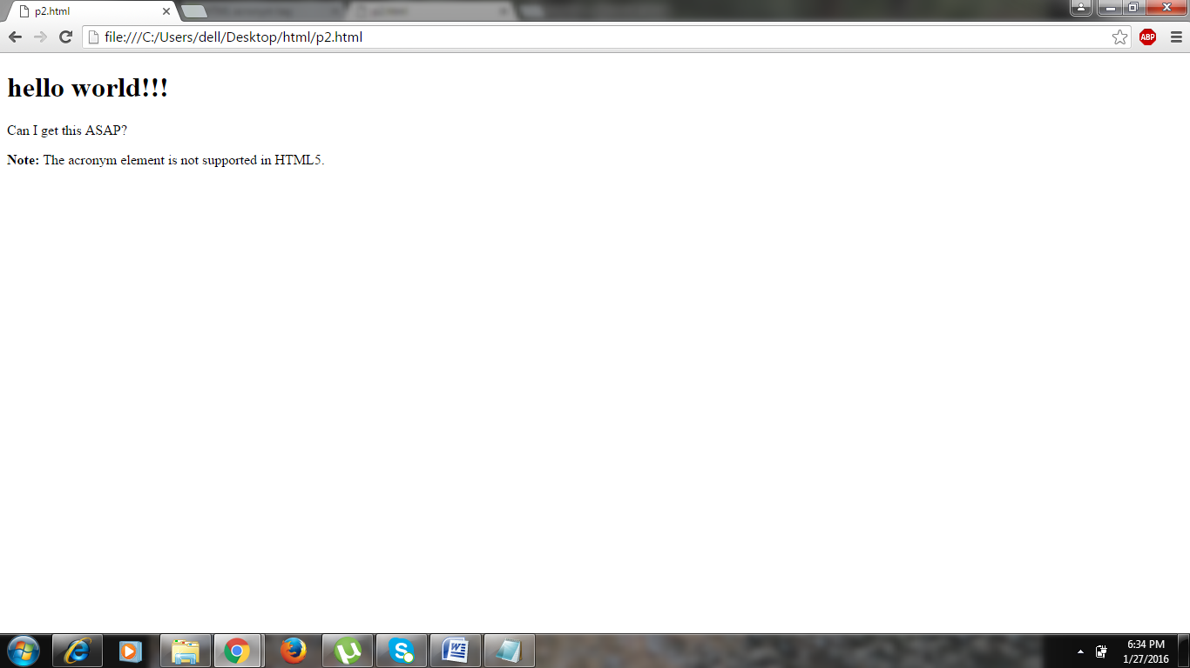

**3.<artical>**

The <article> tag specifies independent, self-contained content.

An article should make sense on its own and it should be possible to distribute it independently from the rest of the site.

Potential sources for the <article> element:

* Forum post
* Blog post
* News story
* Comment

for example

<html>

<head>

<title>artical tag</title>

</head>

<body>

<h3>This is out of article tag</h3>

<article>

<h2>Inside the article tag</h2>

<h2><u>Google Chrome</u></h2>

<p>Google Chrome is a free, open-source web browser developed by Google, released in 2008.</p>

</article>

</body>

</html>

**Output :**

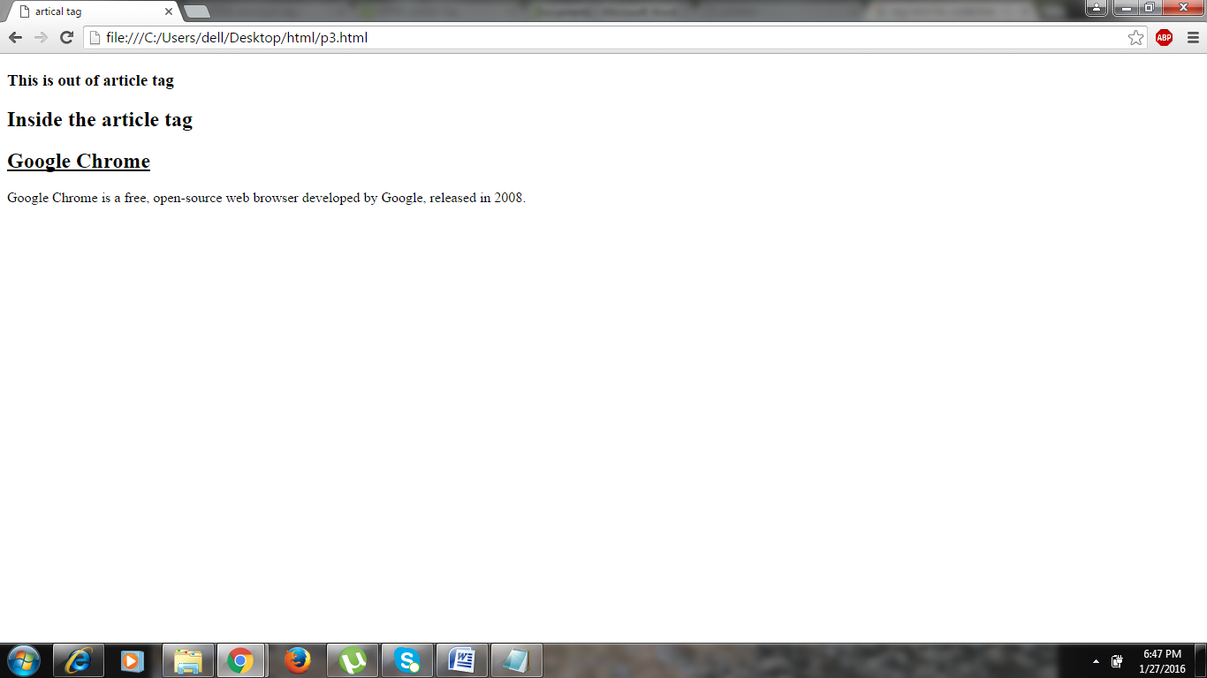

**4.<aside>**

The <aside> tag defines some content aside from the content it is placed in.

The aside content should be related to the surrounding content.

for example.

<!DOCTYPE html>

<html>

<head>

<title>aside tag</title>

</head>

<body>

<p>This is the simple paragraph.</p>

<aside>

<h4>aside tag in html</h4>

<p>This is inside the aside tag in html.</p>

<p>The aside tag defines some content aside from the content it is placed in.

The aside content should be related to the surrounding content.

</p>

</aside>

</body>

</html>

**Output :**

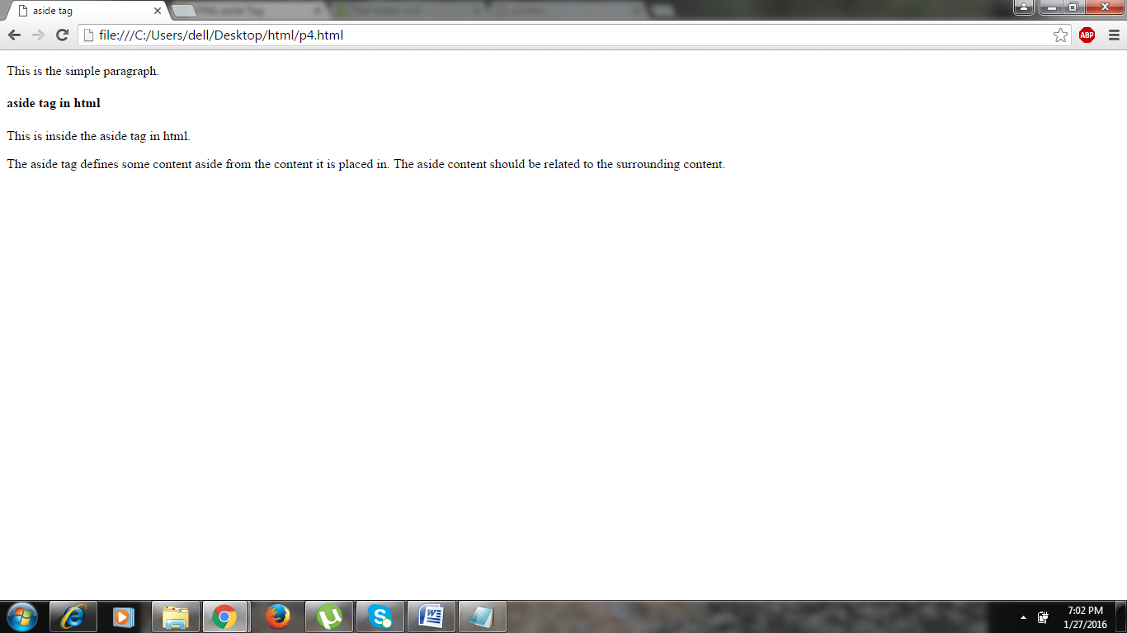

**5.<audio>**

The <audio> tag defines sound, such as music or other audio streams.

Currently, there are 3 supported file formats for the <audio> element: MP3, Wav, and Ogg:

|  |  |  |  |
| --- | --- | --- | --- |
| **Browser** | **MP3** | **Wav** | **Ogg** |
| Internet Explorer | YES | NO | NO |
| Chrome | YES | YES | YES |
| Firefox | YES | YES | YES |
| Safari | YES | YES | NO |
| Opera | YES | YES | YES |

MIME Types for Audio Formats

|  |  |
| --- | --- |
| **Format** | **MIME-type** |
| MP3 | audio/mpeg |
| Ogg | audio/ogg |
| Wav | audio/wav |

for example

<!DOCTYPE html>

<html>

<head>

<title>audio tag</title>

</head>

<body>

<aside>

<h2><u>This is audio tag </u>

</h2>

</aside>

<audio controls>

<source src="horse.ogg" type="audio/ogg">

<source src="horse.mp3" type="audio/mpeg">

Your browser does not support the audio element.

</audio>

</body>

</html>

**Output for audio :**

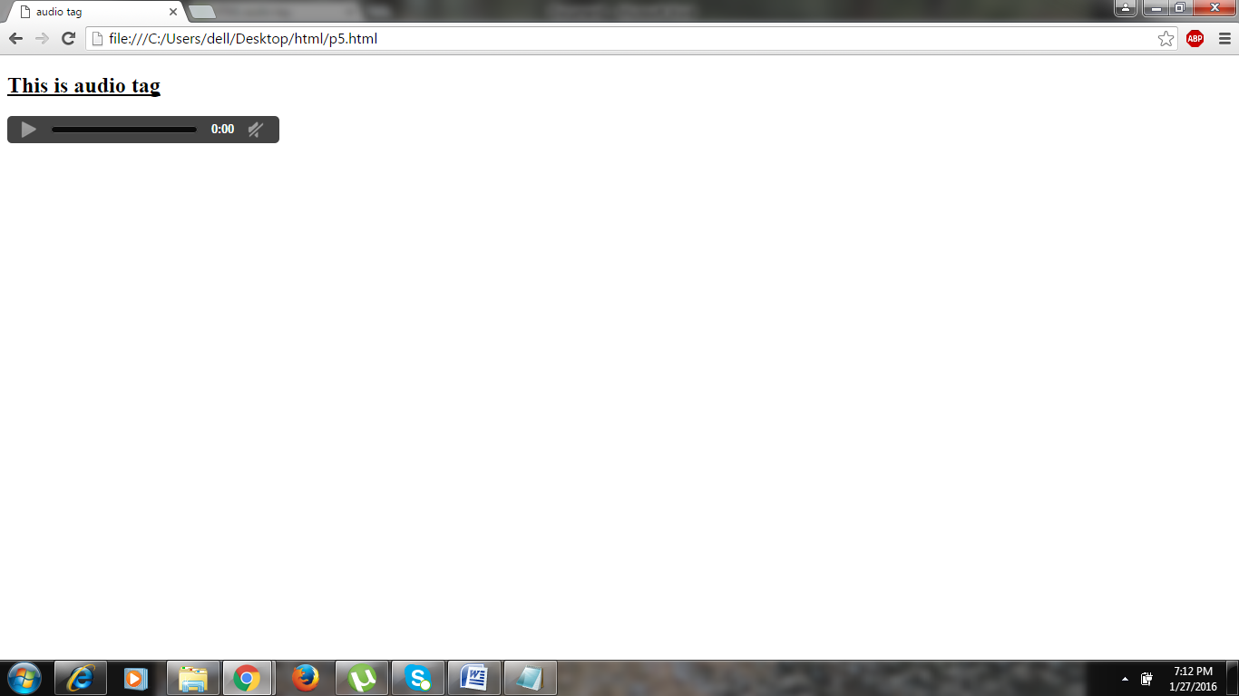

**6.<basefont>**

The <basefont> tag specifies a default text-color, font-size, or font-family for all the text in a document.

The <basefont> tag is not supported in HTML5. Use CSS instead.

for example.

<!DOCTYPE html>

<html>

<head>

<title>basefont tag</title>

<basefont color="blue" size="5">

</head>

<body>

<h2><u><b>Basefont tag</u></b></h2>

<h1 basefont color="red size="5">This is a heading</h1>

<p>This is a sixth html tag which is basefont.</p>

<p>The basefont element is not supported HTML5. Use CSS instead.</p>

</body>

</html>

**Output :**

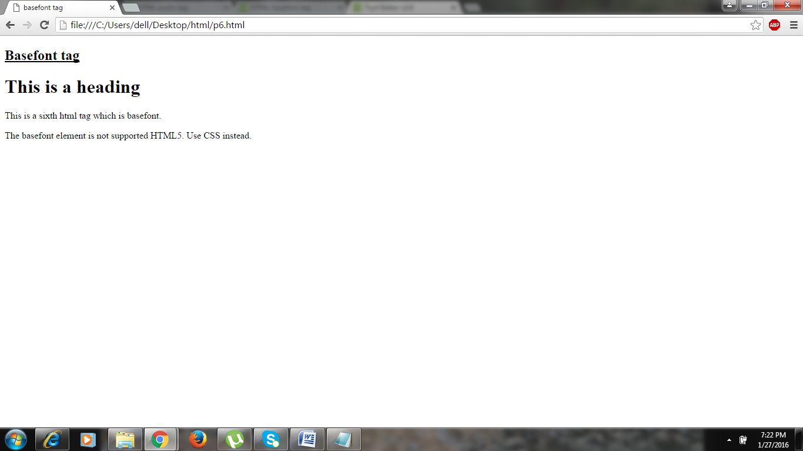

**7.<cite>**

The <cite> tag defines the title of a work (e.g. a book, a song, a movie, a TV show, a painting, a sculpture, etc.).

The HTML Citation Element (**<cite>**) represents a reference to a creative work. It must include the title of a work or a URL reference, which may be in an abbreviated form according to the conventions used for the addition of citation metadata.

for example.

<!DOCTYPE html>

<html>

<head>

<title>cite tag

</title>

</head>

<body>

<p>This is normal by default paragraph which does not defines any title of any work .

</p>

<p><cite><u>Ramleela</u></cite></p>

<p>

Ramleela movie is producing by sanjay leela bhansali. released in 2013.</p>

</body>

</html>

**Output :**

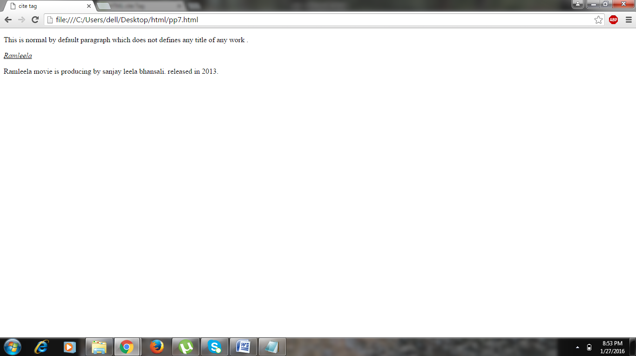

**8.<dialog>**

The <dialog> tag defines a dialog box or window.

The <dialog> element makes it easy to create popup dialogs and modals on a web page.

for example

<html>

<head>

<style>

</style>

</head>

<body>

<p><b>Note:</b> Dialog tag defines a dialog box or window.</p>

<table border="01">

<tr>

<th>January <dialog open>This is an open dialog window</dialog></th>

<th>February</th>

<th>March</th>

</tr>

<tr>

<td>31</td>

<td>28</td>

<td>31</td>

</tr>

</table>

</body>

</html>

**Output :**

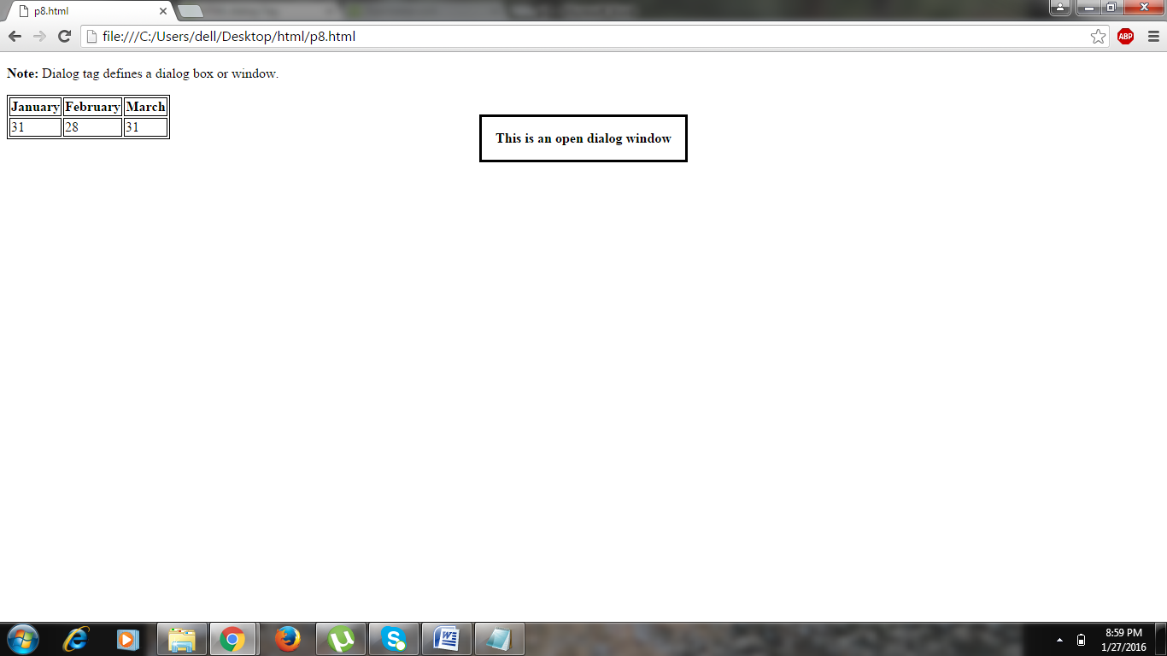

**9.<details>**

The <details> tag specifies additional details that the user can view or hide on demand.

The <details> tag can be used to create an interactive widget that the user can open and close. Any sort of content can be put inside the <details> tag.

The content of a <details> element should not be visible unless the open attribute is set.

for example.

<!DOCTYPE html>

<html>

<head>

<title>Summary tag</title>

</head>

<body>

<details>

<summary>Copyright 1999-2014.</summary>

<p> - by Refsnes Data. All Rights Reserved.</p>

<p>All content and graphics on this web site are the property of the company Refsnes Data.</p>

</details>

<p><b>Note:</b> The details tag is currently only supported in Opera, Chrome, and in Safari 6.</p>

</body>

</html>

**Output :**

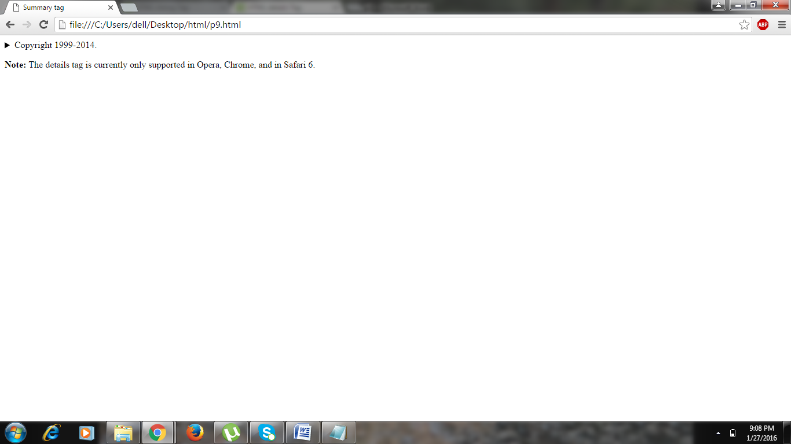

**10.<em>**

The <em> tag is a phrase tag. It renders as emphasized text.

**Tip:** This tag is not deprecated, but it is possible to achieve richer effect with CSS.

for example

<!DOCTYPE html>

<html>

<head>

<title>emphrase tag

</title>

</head>

<body>

<p>This paragraph is written only in default font format.</p>

<em>Emphasized text</em><br>

<strong>Strong text</strong><br>

<code>A piece of computer code</code><br>

<samp>Sample output from a computer program</samp><br>

<kbd>Keyboard input</kbd><br>

<var>Variable</var>

</body>

</html>

**Output :**

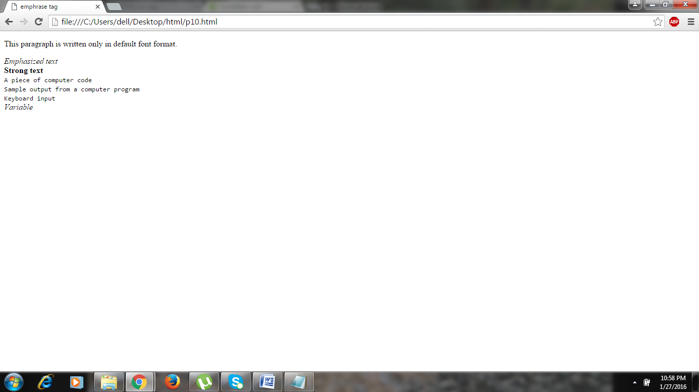

**11.<field set>**

The <fieldset> tag is used to group related elements in a form.

The <fieldset> tag draws a box around the related elements.

for example.

<!DOCTYPE html>

<html>

<head>

<title>field set tag

</title>

</head>

<body>

<form>

<fieldset>

<legend>Personal data:</legend>

Name: <input type="text"><br>

Email: <input type="text"><br>

Date of birth: <input type="text">

<p>Thank you for submit your data into this form</p>

</fieldset>

</form>

</body>

</html>

**Output :**

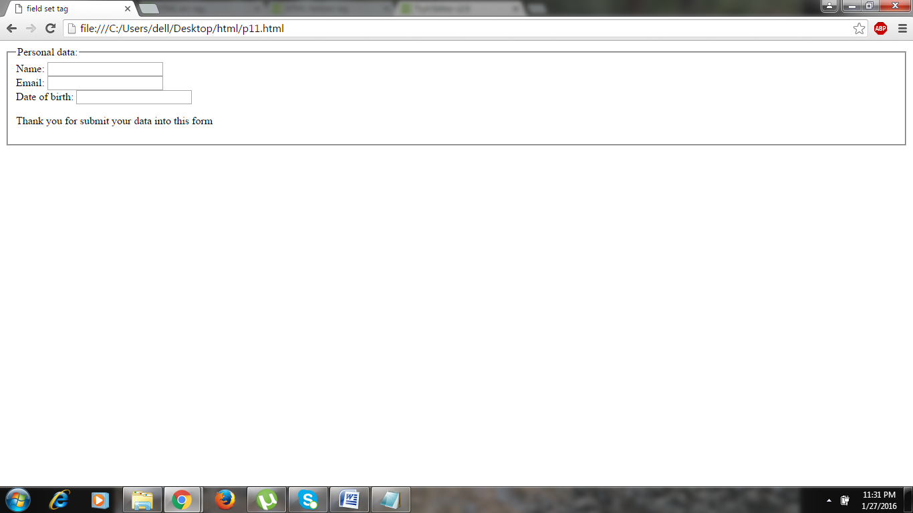

**12.<figcaption>**

The <figcaption> tag defines a caption for a [<figure>](http://www.w3schools.com/tags/tag_figure.asp) element.

The <figcaption> element can be placed as the first or last child of the <figure> element.

for example

<!DOCTYPE html>

<html>

<head

<title>figcaption tag

</title>

</head>

<body>

<p>Mount Everest, also known in Nepal as Sagarmāthā and in Tibet as Chomolungma, is Earth's highest mountain. It is located in the Mahalangur mountain range in Nepal and Tibet. Its peak is 8,848 metres (29,029 ft) above sea level. It is not the furthest summit from the centre of the Earth.</p>

<figure>

<img src="desktop:/html/download.jpg" alt="Mount averest" width="304" height="228">

<figcaption>Fig.1 - A view of the Mount Averest.</figcaption>

</figure>

</body>

</html>

**Output :**

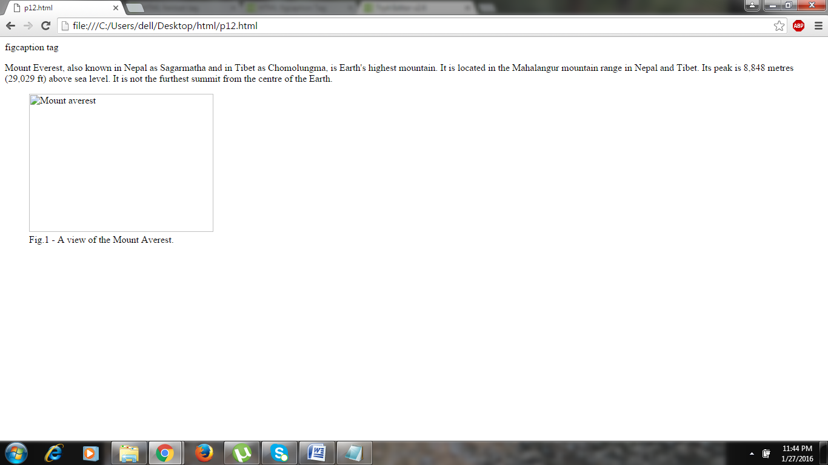

**13.<legend>**

The <legend> tag defines a caption for the [<fieldset>](http://www.w3schools.com/tags/tag_fieldset.asp) element.

for example

<!DOCTYPE html>

<html>

<head>

<title>HTML legend Tag</title>

</head>

<body>

<form>

<fieldset>

<legend>Details</legend>

Student Name: <input type="text"><br />

BE Subjects:<input type="text"><br />

Enrollment No:<input type="text"></br>

Course Link:<input type="url" name="websitelink">

</fieldset>

</form>

</body>

</html>

**Output :**

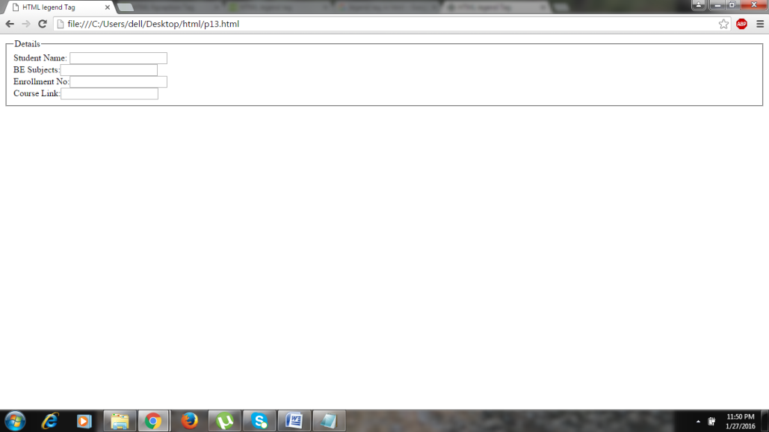

**14.<map>**

The <map> tag is used to define a client-side image-map. An image-map is an image with clickable areas.

The required name attribute of the <map> element is associated with the <img>'s usemap attribute and creates a relationship between the image and the map.

The <map> element contains a number of area elements, that defines the clickable areas in the image map.

for example

<!DOCTYPE html>

<html>

<body>

<p>Click on the sun or on one of the planets to watch it closer:</p>

<img src="planets.gif" width="145" height="126" alt="Planets" usemap="#planetmap">

<map name="planetmap">

<area shape="rect" coords="0,0,82,126" alt="Sun" href="sun.htm">

<area shape="circle" coords="90,58,3" alt="Mercury" href="mercur.htm">

<area shape="circle" coords="124,58,8" alt="Venus" href="venus.htm">

</map>

</body>

</html>

**Output :**

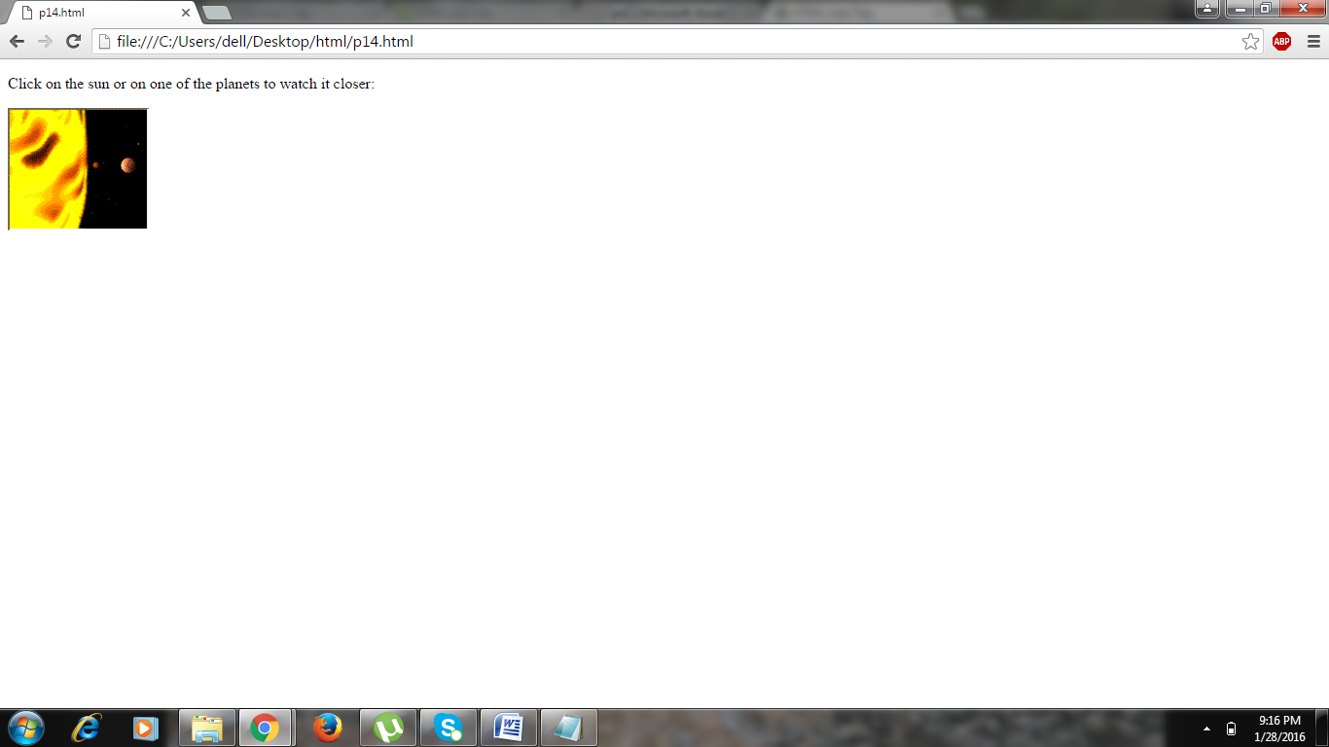

**15.<mark>**

The <mark> tag defines marked text.

Use the <mark> tag if you want to highlight parts of your text.

for example

<!DOCTYPE html>

<html>

<head>

<title>mark tag

</title>

</head>

<body>

<p>Hello !!!!!</p>

<p>today is a <mark><u>sunday....</u></mark></p>

<p>Do not forget to buy <mark>milk</mark> today.</p>

</body>

</html>

**Output :**

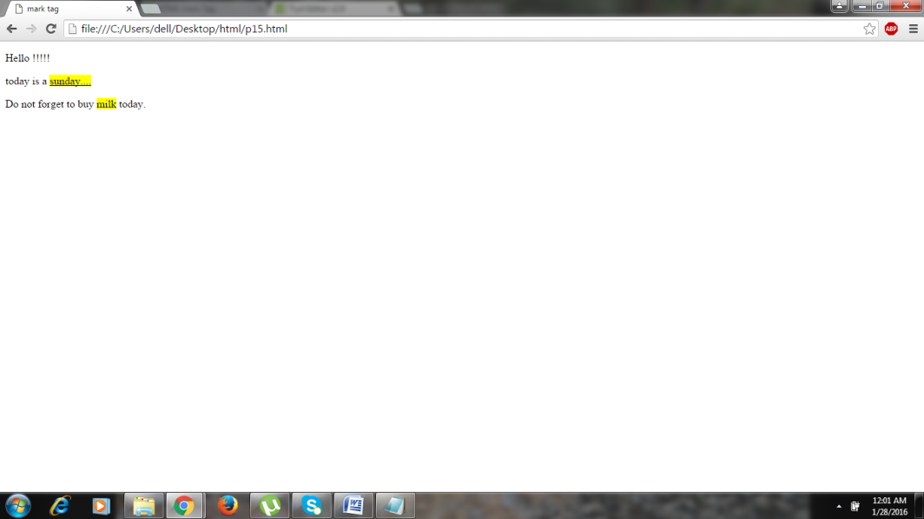

**16.<meter>**

The <meter> tag defines a scalar measurement within a known range, or a fractional value. This is also known as a gauge.

Examples: Disk usage, the relevance of a query result, etc.

for example

<!DOCTYPE html>

<html>

<head>

<title>

meter tag

</title>

</head>

<body>

<p>Display available space:</p>

<meter value="2" min="0" max="10">2 out of 10</meter><br>

<meter value="0.6">60%</meter>

<p><strong>Note:</strong> The meter tag is not supported in Internet Explore.</p>

</body>

</html>

**Output :**

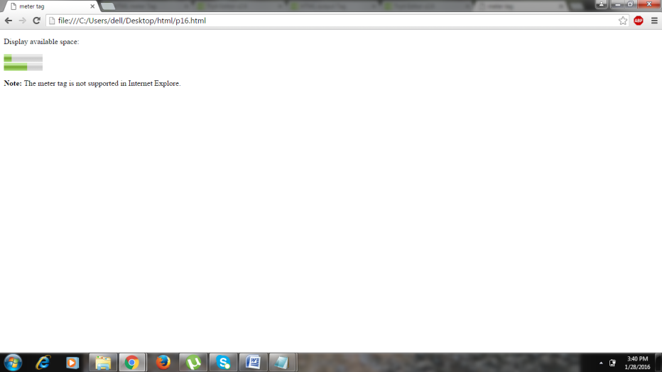

**17.<output>**

The <output> tag represents the result of a calculation (like one performed by a script).

for example

<!DOCTYPE html>

<html>

<head>

<title>

output tag</title>

</head>

<body>

<fieldset>

<legend>value:</legend>

<form oninput="x.value=parseInt(a.value)+parseInt(b.value)">0

<input type="range" id="a" value="50">100

+<input type="number" id="b" value="50">

=<output name="x" for="a b"></output>

</fieldset>

</form>

<p><strong>Note:</strong> The output tag is not supported in Internet Explorer.</p>

</body>

</html>

**Output :**

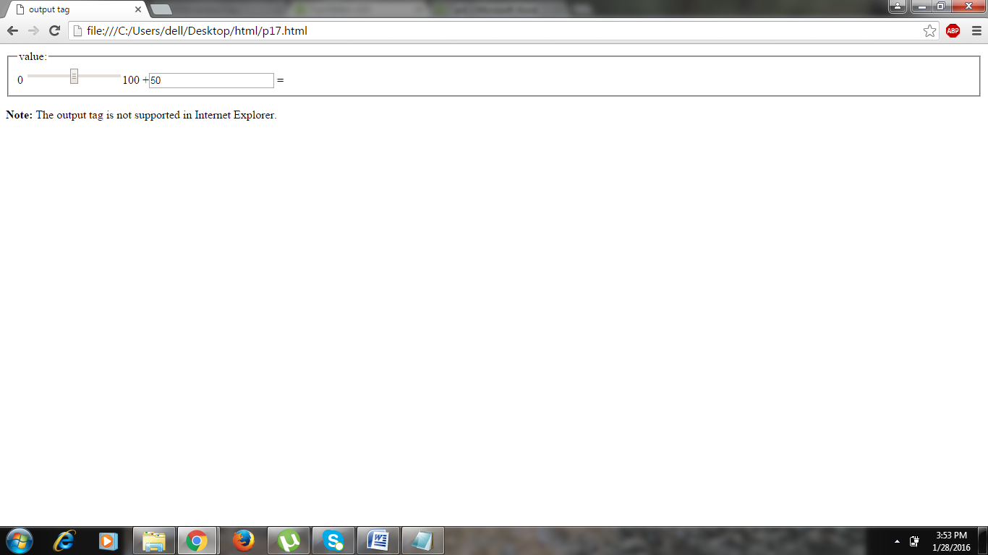

**18.<progress>**

The <progress> tag represents the progress of a task.

for example.

<!DOCTYPE html>

<html>

<head>

<title>

progress tag

</title>

</head>

<body>

<p>Process state:</p>

<meter value="2" min="0" max="10">2 out of 10</meter><br>

<meter value="0.6">60%</meter>

<p>Out of 10 there are 2 process is done</p>

<h3><u>Downloading progress:</u></h3>

<progress value="22" max="100">

</progress>

<p><strong>Note:</strong> The progress tag is not supported in Internet Explorer 9 and earlier versions.</p>

</body>

</html>

**Output :**

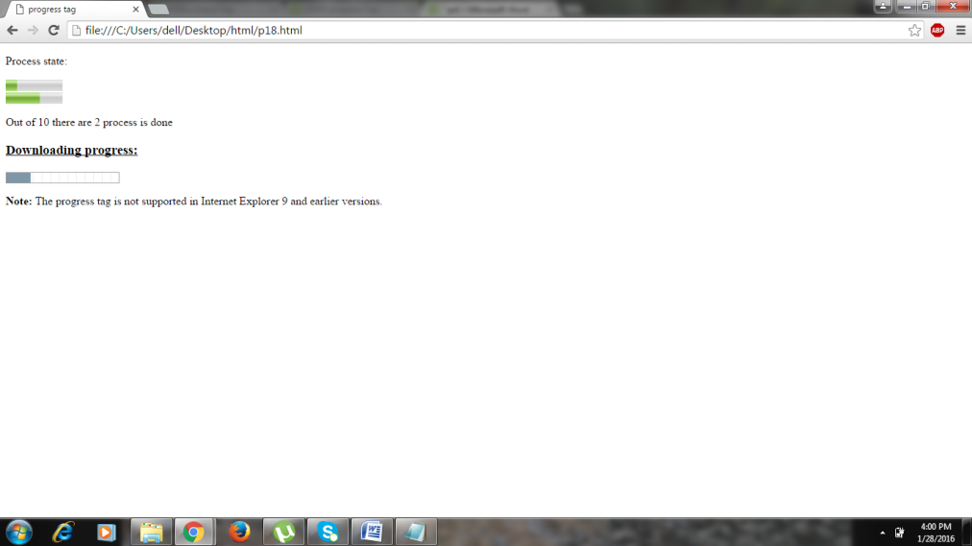

**19.<rp>**

The <rp> tag can be used to provide parentheses around a ruby text, to be shown by browsers that do not support ruby annotations.

Use the <rp> tag together with the [<ruby>](http://www.w3schools.com/tags/tag_ruby.asp) and the [<rt>](http://www.w3schools.com/tags/tag_rt.asp) tags: The <ruby> element consists of one or more characters that needs an explanation/pronunciation, and an <rt> element that gives that information, and an optional <rp> element that defines what to show for browsers that not support ruby annotations.

for example

<!DOCTYPE html>

<html>

<head>

<title>

rp tag

</title>

</head>

<body>

<p>This is a simple paragraph.</p>

<ruby>

<p>This is a paragraph which used for rp in the ruby tag.</p>

漢 <rt><rp>(</rp>ㄏㄢˋ<rp>)</rp></rt>

</ruby>

</body>

</html>

**Output :**

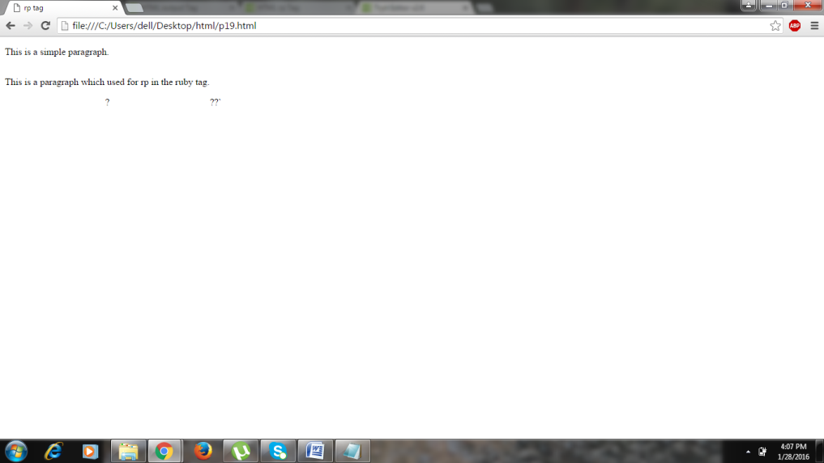

**20.<samp>**

The <samp> tag is a phrase tag. It defines sample output from a computer program.

**Tip:** This tag is not deprecated, but it is possible to achieve richer effect with CSS.

for example

<!DOCTYPE html>

<html>

<head>

<title>samp tag

</title>

<body>

<cite>Different Text phrase:</cite>

<p>By default text </p>

<em>Emphasized text</em><br>

<strong>Strong text</strong><br>

<code>A piece of computer code</code><br>

<samp><u>Sample output from a computer program</u></samp><br>

<kbd>Keyboard input</kbd><br>

<var>Variable</var>

</body>

</html>

**Output :**

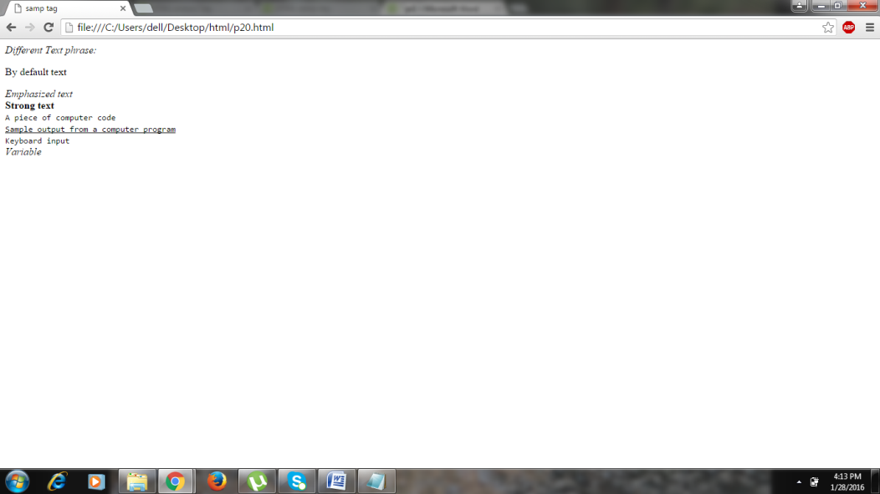

**21.<span>**

The <span> tag is used to group inline-elements in a document.

The <span> tag provides no visual change by itself.

The <span> tag provides a way to add a hook to a part of a text or a part of a document.

for example

<!DOCTYPE html>

<html>

<head>

<title>span tag</title>

</head>

<body>

<p><em>This text is written in emphasis phrase</em></p>

<p>My mother has <span style="color:blue;font-weight:bold">blue</span> eyes and my father has <span style="color:darkolivegreen;font-weight:bold">dark green</span> eyes.</p>

</body>

</html>

**Output :**

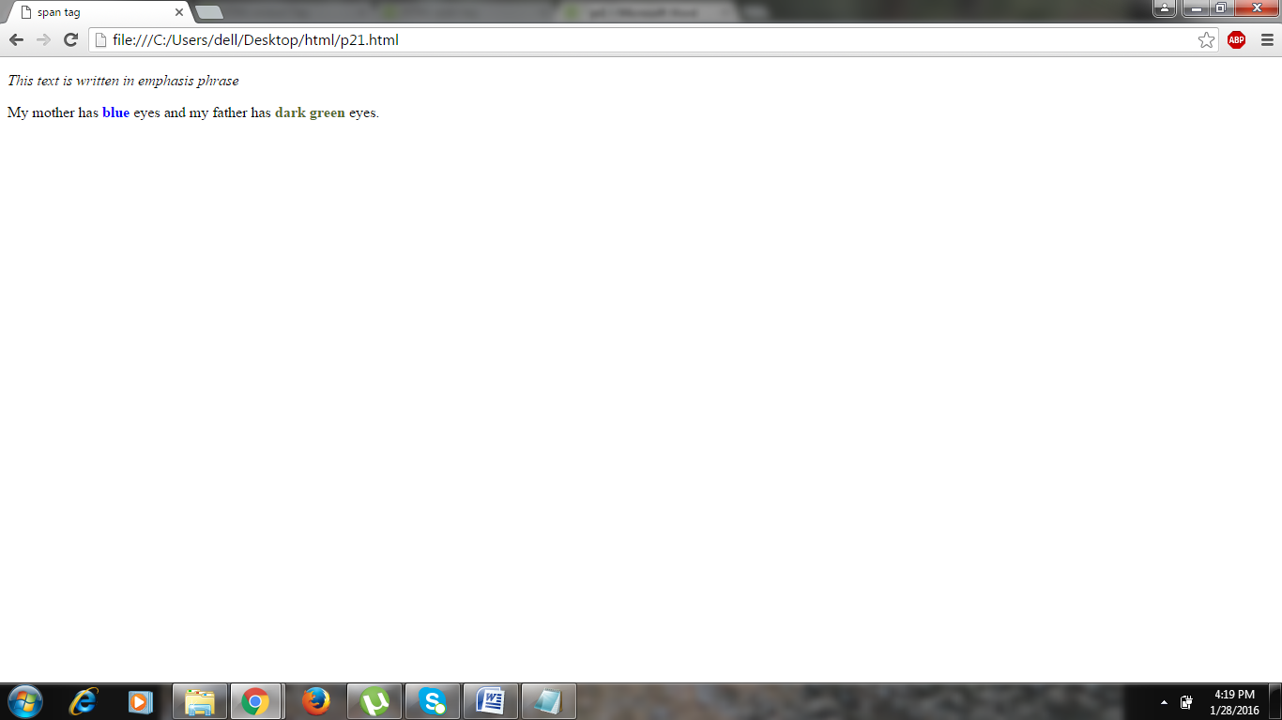

**22.<strike>**

The HTML <strike> tag specifies strikethrough text. This tag is deprecated now, <del> should be used instead.

for example

<!DOCTYPE html>

<html>

<head>

<title>strike tag

</title>

</head>

<body>

<table border="2">

<tr>

<td>

<p>Version 2.0 is <strike>not yet available!</strike> now available!</p>

</td>

</tr>

<tr>

<td>

<p>The strike tag</p>

</td>

</tr>

</table>

<p>The strike tag is used for check the entire data</p>

</body>

</html>

**Output :**

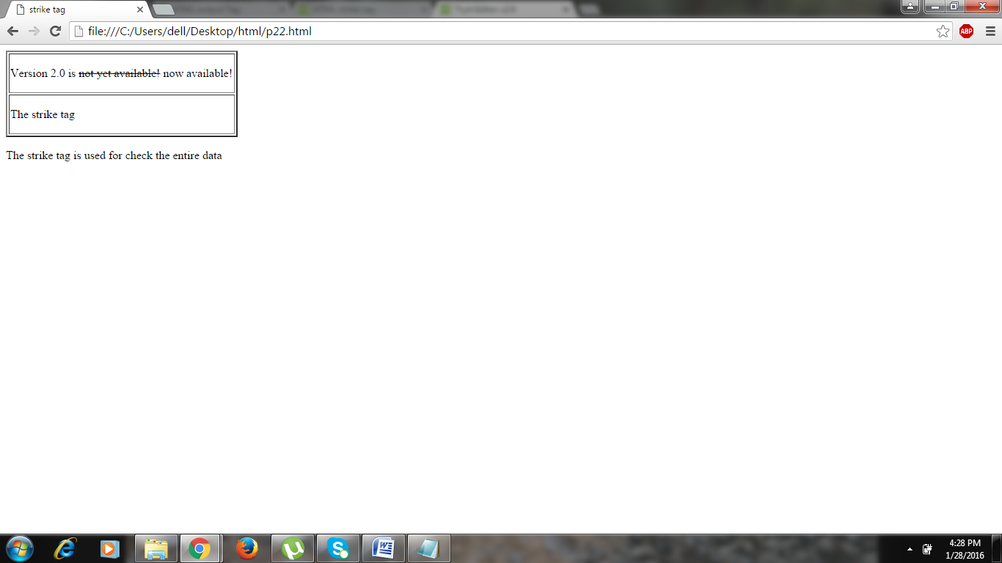

**23.<summary>**

The <summary> tag defines a visible heading for the details element. The heading can be clicked to view/hide the details.

for example.

<!DOCTYPE html>

<html>

<head>

<title>summary tag</title>

</head>

<body>

<details>

<summary><u>Alert for Exams.</u></summary>

<p> - by H.O.D .</p>

<p>Your exams are statrted after a Week.keep learning</p>

</details>

<p><b>Note:</b> The summary element is currently supported only in Chrome, Safari 6+ and Opera 15+.</p>

</body>

</html>

**Output :**

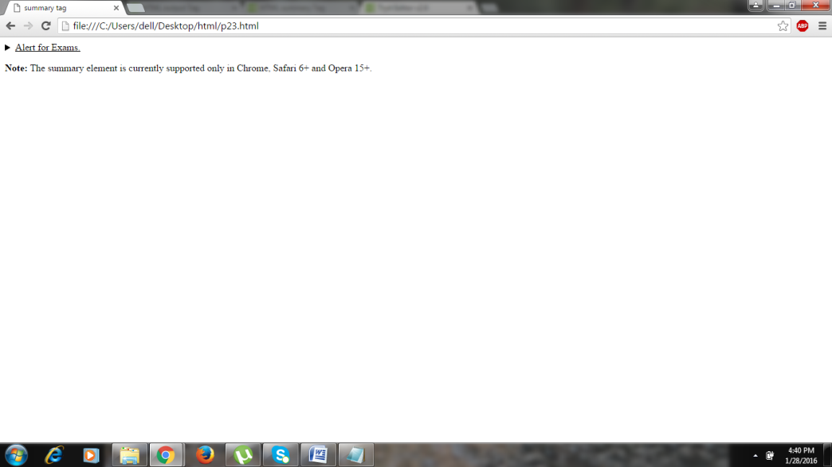

**24.<textarea>**

The <textarea> tag defines a multi-line text input control.

A text area can hold an unlimited number of characters, and the text renders in a fixed-width font (usually Courier).

The size of a text area can be specified by the cols and rows attributes, or even better; through CSS' height and width properties.

for example

<!DOCTYPE html>

<html>

<head>

<title>Textarea tag

</title>

<body>

<table border="2">

<tr>

<td>Name:</td>

<td>

<input type="text" name="textbox1">

</td>

</tr>

<tr>

<td>Address:</td>

<td>

<textarea rows="4" cols="50">

</textarea>

</td>

</tr>

</table>

</body>

</html>

**Output for textarea:**

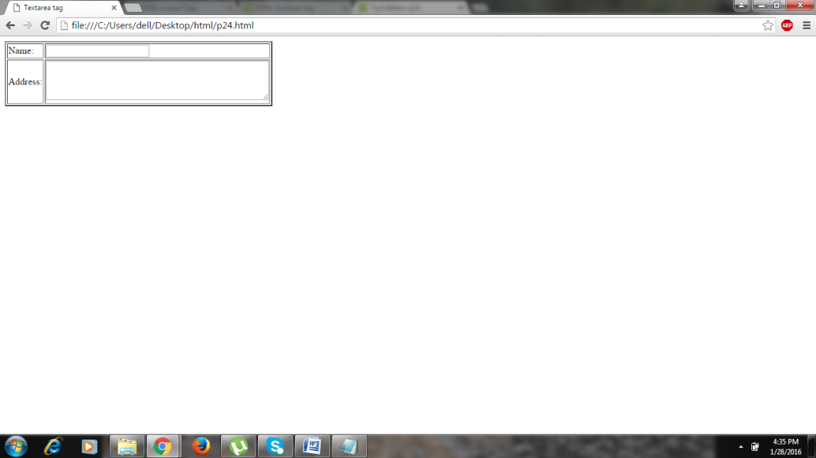

**25.<tfoot>**

The <tfoot> tag is used to group footer content in an HTML table.

The <tfoot> element is used in conjunction with the [<thead>](http://www.w3schools.com/tags/tag_thead.asp) and [<tbody>](http://www.w3schools.com/tags/tag_tbody.asp) elements to specify each part of a table (footer, header, body).

Browsers can use these elements to enable scrolling of the table body independently of the header and footer. Also, when printing a large table that spans multiple pages, these elements can enable the table header and footer to be printed at the top and bottom of each page.

The <tfoot> tag must be used in the following context: As a child of a <table> element, after any <caption>, <colgroup>, and <thead> elements and before any <tbody> and <tr> elements.

for example.

<!DOCTYPE html>

<html>

<head>

<title>tfoot tag</title>

<style>

thead {color:black;}

tbody {color:black;}

tfoot {color:red;}

table, th, td {

border: 1px solid black;

}

</style>

</head>

<body>

<table>

<thead>

<tr>

<th>Month</th>

<th>Savings</th>

</tr>

</thead>

<tfoot>

<tr>

<td>Sum</td>

<td>$180</td>

</tr>

</tfoot>

<tbody>

<tr>

<td>January</td>

<td>$100</td>

</tr>

<tr>

<td>February</td>

<td>$80</td>

</tr>

</tbody>

</table>

<p><b>Tip:</b> The thead, tbody, and tfoot elements will not affect the layout of the table by default.</p>

</body>

</html>

**Output :**

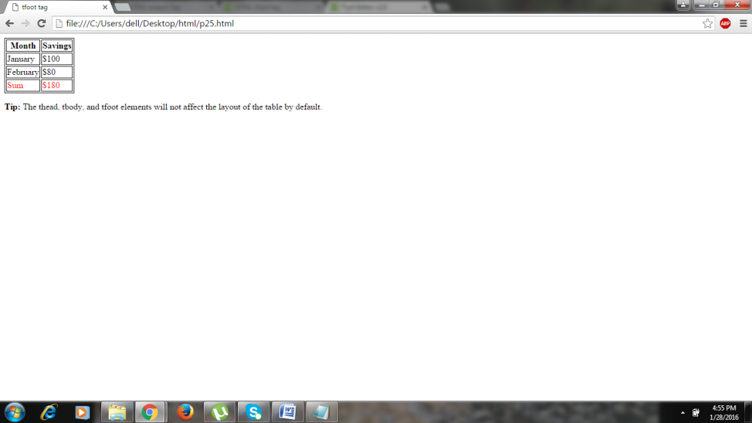

**26.<thead>**

The <thead> tag is used to group header content in an HTML table.

The <thead> element is used in conjunction with the tbody and tfoot elements to specify each part of a table (header, body, footer).

Browsers can use these elements to enable scrolling of the table body independently of the header and footer. Also, when printing a large table that spans multiple pages, these elements can enable the table header and footer to be printed at the top and bottom of each page.

The <thead> tag must be used in the following context: As a child of a <table> element, after any <caption>, and <colgroup> elements, and before any <tbody>, <tfoot>, and <tr> elements.

for example

<!DOCTYPE html>

<html>

<head>

<style>

thead {color:red;}

tbody {color:black;}

tfoot {color:black;}

table, th, td {

border: 1px solid black;

}

</style>

</head>

<body>

<table>

<thead>

<tr>

<th>Month</th>

<th>Savings</th>

</tr>

</thead>

<tfoot>

<tr>

<td>Sum</td>

<td>$180</td>

</tr>

</tfoot>

<tbody>

<tr>

<td>January</td>

<td>$100</td>

</tr>

<tr>

<td>February</td>

<td>$80</td>

</tr>

</tbody>

</table>

<p><b>Tip:</b> The thead, tbody, and tfoot elements will not affect the layout of the table by default. </p>

</body>

</html>

**Output :**

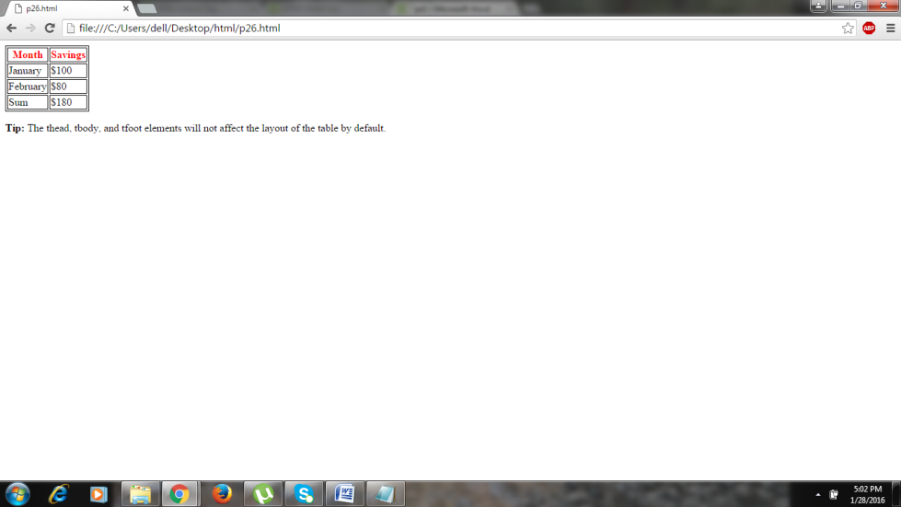

**27.<track>**

The <track> tag specifies text tracks for media elements (<audio> and <video>).

This element is used to specify subtitles, caption files or other files containing text, that should be visible when the media is playing.

for example

<html>

<head>

<title>track tag</title>

</head>

<body>

<p>The video is below:</p>

<fieldset>

<legend>video</legend>

<video controls>

<source src="rolling_sample.mp4" type="video/mp4">

<track src="rolling_sample.vtt" label="English subtitles" kind="subtitles" srclang="en" default>

<track src="rolling_sample.vtt" label="Hindi subtitles" kind="subtitles" srclang="hi" >

Display this message, if your browser does not support video tag.

</video>

</fieldset>

</body>

</html>

**Output :**

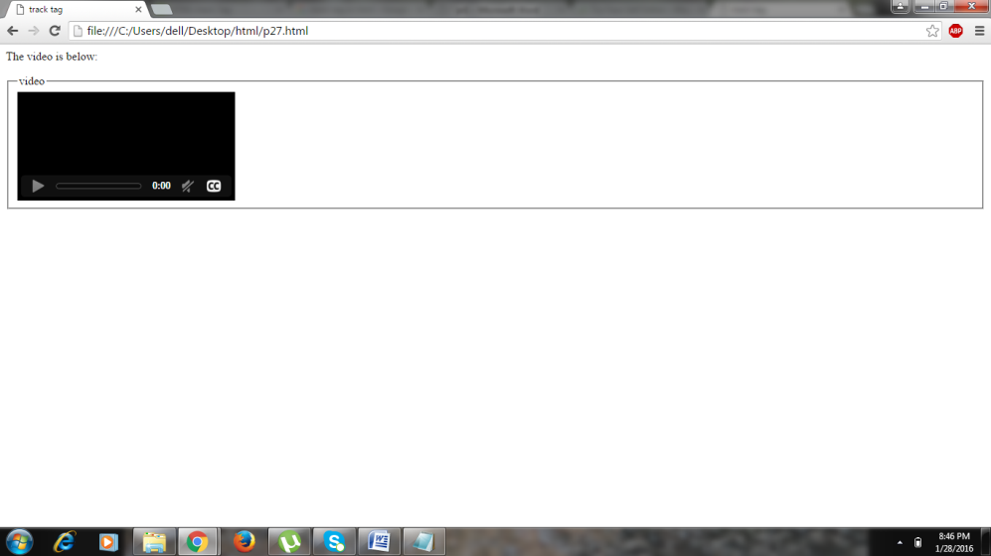

**28.<tt>**

The HTML Teletype Text Element (<tt>) produces an inline element displayed in the browser's default monotype font. This element was intended to style text as it would display on a fixed width display, such as a teletype. It probably is more common to display fixed width type using the code element.

for example

<!DOCTYPE html>

<html>

<head>

<title>tt tag</title>

</head>

<body>

<p>This text is normal.</p>

<p>This text is written into emphrase.</p>

<p><tt><u>This text is teletype text.</u></tt></p>

<p><tt>Let's see the demo</tt></p>

<table border="3">

<tr>

<td><tt>NAME:</tt></td>

<td><tt>kinjal bhatt</tt></td>

</tr>

<tr>

<td><tt>CONTACT NO:</tt></td>

<td><tt>8980456558</tt></td>

</tr>

</table>

</body>

</html>

**Output :**

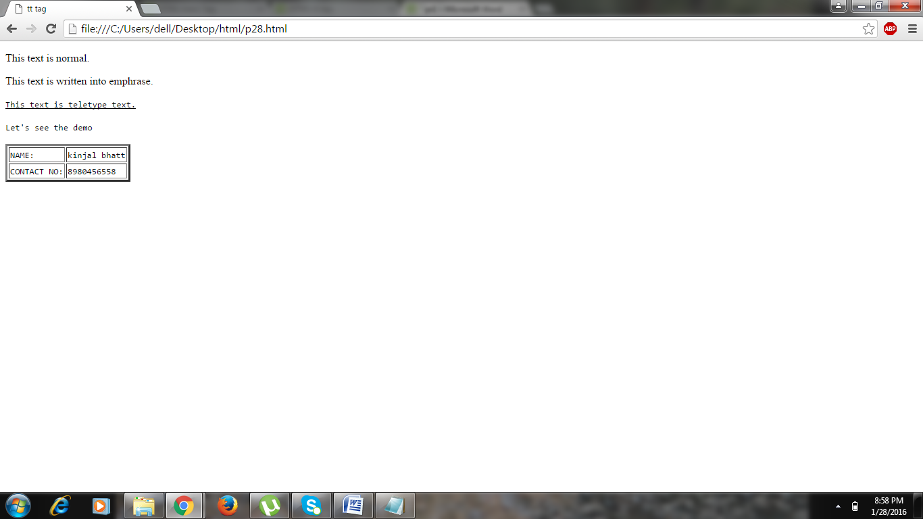

**29.<video>**

The <video> tag specifies video, such as a movie clip or other video streams.

Currently, there are 3 supported video formats for the <video> element: MP4, WebM, and Ogg:

for example

<!DOCTYPE html>

<html>

<head>

<title>video tag</title>

</head>

<body>

<p><tt>Video : </tt></p>

<p><h3>Your browser does not support the video tag.</h3></p>

<video width="380" height="270" controls>

<source src="movie.mp4" type="video/mp4">

<source src="movie.ogg" type="video/ogg">

<p><h3>Your browser does not support the video tag.</h3></p>

</video>

</body>

</html>

**Output :**

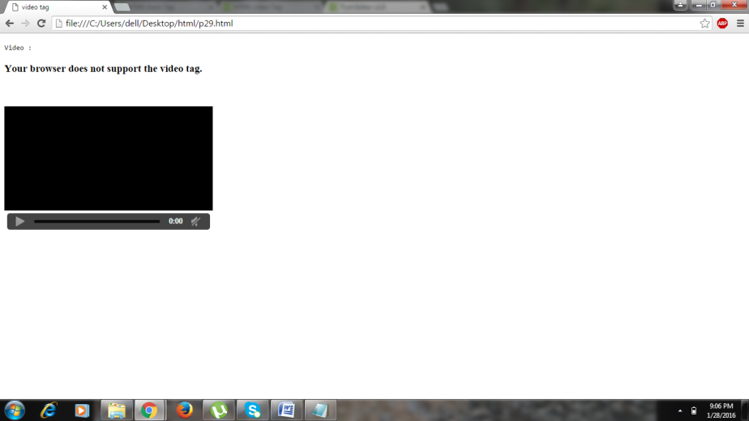

**30.<wbr>**

The <wbr> (Word Break Opportunity) tag specifies where in a text it would be ok to add a line-break.

**Tip:** When a word is too long, or you are afraid that the browser will break your lines at the wrong place, you can use the <wbr> element to add word break opportunities.

for example

<!DOCTYPE html>

<html>

<head>

<title>HTML wbr Tag</title>

</head>

<body>

<wbr />

the browser to extend the document window beyond the size of the viewing pane and the poor user must scroll right

<wbr />

</body>

</html>

**Output :**

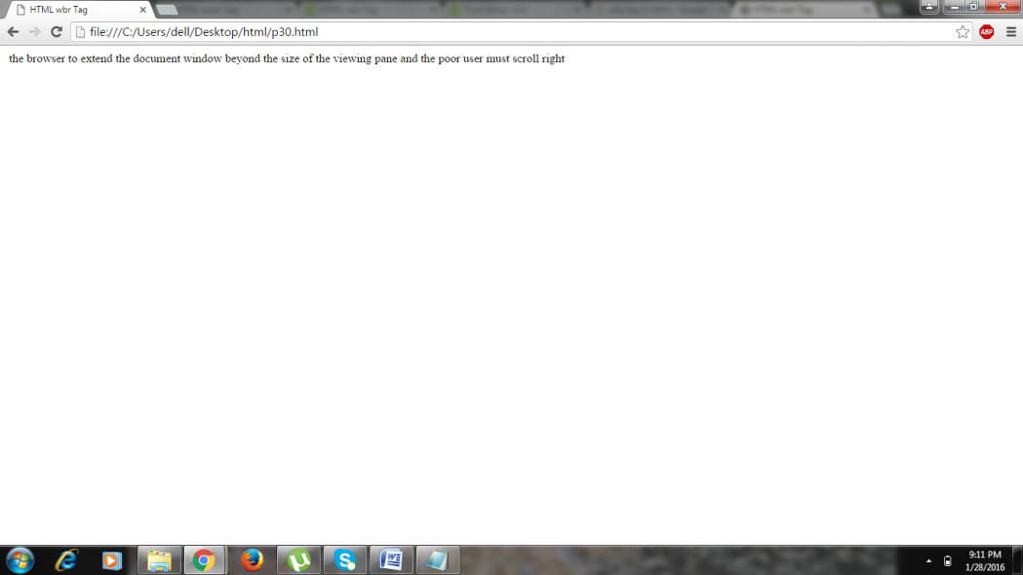

**>> try to make a web-page which can encapsulate all above tag (minimum 15) in it.**

<!-- <!DOCTYPE> tag is used -->

<!DOCTYPE html>

<html>

<head>

<title> Upcomming Xiaomi MI5</title>

</head>

<body>

<div style="background-color:grey;

color:white;

text-align:center;

padding:5px;">

<h1>Welcome</h1>

</div>

<div>

<!-- <figcaption> tag is used -->

<figure >

<img src="mi5.jpg" alt="Xiaomi Mi 5" width="500" height="300">

<figcaption>Fig. - Xiaomi Mi 5.</figcaption>

</figure>

<!-- <artical> and <cite> tag is used -->

<article>

<h1>Upcomming Xiaomi MI5</h1>

<!-- <strike> and <em>tag is used -->

<p><cite>Xiaomi's upcoming Mi 5</cite> flagship smartphone will come with <strike>single-SIM</strike> <em>dual-SIM</em> functionality as well as support for NFC.</p>

</article>

<!-- <fieldset> and <legend>tag is used -->

<fieldset>

<!-- <tt> tag is used -->

<legend><tt>Specification:</tt></legend>

<p>&#9899; 5.3" 1440x2560 pixels Screen</p>

<p>&#9899; 16MP 2160p Camera</p>

<p>&#9899; 4GB Snapdragon 820 RAM</p>

<p>&#9899;3030 mAh Li-Po Battery</p>

<p>&#9899; Support 4G, 3G, NFC</p>

<!-- <span> tag is used -->

More detail is loading... <span style="color:blue">Please wait</span>

<!-- <process> tag is used -->

<progress value="88" max="100"></progress>

<br>

<!-- <mark> tag is used -->

Rating for <mark> Xiaomi Mi5 </mark> <meter value="9" min="0" max="10">9 out of 10</meter> 9/10<br>

</fieldset>

<!-- <acronym> tag is used-->

<p>When MI5 is <acronym title="on 24 Feb 2016">available in india</acronym>? </p>

<!-- <textarea> tag is used -->

<textarea>Leave your comment here</textarea>

<!-- Used <details> and <summary> tag -->

</div>

<div style="background-color:black; color:white; clear:both; text-align:center; padding:5px;">

<details>

<summary>Copyright 2016.</summary>

<p> - by Sandip Chaudhari Blog All Rights Reserved.</p>

<p>All content and graphics on this web site are the property of the owner.</p>

</details>

</div>

</body>

</html>

**Output :**

